**Online Sales and Inventory**

**Management for Electronic Store**

**By**

**Sameer Makwana**

**09BCE026**



**DEPARTMENT OF COMPUTER SCIENCE & ENGINEERING**

**Ahmedabad 382481**

**Online Sales and Inventory**

**Management for Electronic Store**

**Seminar**

Submitted in fulfillment of the requirements

For the degree of

**Bachelor of Technology in Computer Engineering/Information Technology**

By

**Sameer Makwana**

**09BCE026**

Guided By

**Prof. Malaram Kumhar**

**[DEPARTMENT OF COMPUTER SCIENCE & ENGINEERING]**



**DEPARTMENT OF COMPUTER SCIENCE & ENGINEERING**

**Ahmedabad 382481**

CERTIFICATE

This is to certify that the Seminar entitled “Online Sales and Inventory Management for Electronic Store” submitted by Makwana Sameer Rameshchandra (09BCE026) , towards the partial fulfillment of the requirements for the degree of Bachelor of Technology inComputer Engineering/ Information Technology of Nirma University is the record of work carried out by him/her under my supervision and guidance. In my opinion, the submitted work has reached a level required for being accepted for examination.

Prof. Malaram Kumhar Prof.Sanjay Garg

Assistant Professor Dept. of Computer Science & Engg.,

Department of Computer Science & Engg., Institute of Technology,

Institute of Technology, Nirma University,

Nirma University, Ahmedabad

Ahmedabad

**ACKNOWLEDGEMENT**

It gives me great pleasure in expressing thanks and profound gratitude to I like to give my special thanks to Mr. Malaram Kumhar, Project guide, for his continual support throughout the project Work. I heartily thankful to his for his time to time suggestion and the clarity of the concepts of the topic that helped me a lot during this study.

I am also thankful to Prof Sanjay Garg, Head, Department of CE, IT and MCA Department, Institute of Technology, Nirma University, Ahmedabad for his continual kind words of encouragement and motivation throughout the Major Project. I am also thankful to Dr K Kotecha, Director, Institute of Technology for his kind support in all respect during my study.

I am thankful to all faculty members of Department of Computer Engineering, Nirma University, Ahmedabad for their special attention and suggestions towards the project work.

The blessings of God and my family members makes the way for completion of major project. I am very much grateful to them.

The friends, who always bear and motivate me throughout this course, I am thankful to them.

Sameer Makwana

09BCE026

**ABSTRACT/ Outline**

Online sales is a very important feature used in e-commerce to assist people making purchases online. The Business-to-Customer aspect of electronic commerce (e-commerce) is the most visible business use of the World Wide Web. The primary goal of an e-commerce site is to sell goods and services online.

E-commerce is fast gaining ground as an accepted and used business paradigm. More and more business houses are implementing web site providing functionality for performing commercial transactions over the web. It is reasonable to say that the process of shopping on the web is becoming commonplace.

Shopping Cart feature allows online shopping customers to “place” items in the cart. Upon “checkout” the software calculates as total for the order including shipping and handling postage, packing and taxes, if applicable. The Shopping Cart is very important feature used in e-commerce to assist people making purchases products online. It provides the user a catalog of different products available in the system. In order to purchase a shopping cart is provided to the user. The shopping cart application has been developed to allow business grows larger and faster. This site will let customers to view and order products online from any part of the world. Under this website many products and services can be ordered. The shopping cart is expanded permanently through new products and services in order to offer a product portfolio corresponding to the market.

**CONTENTS**

Certificate

Acknowledgement

Abstract

Table of Contents

List of figures

List of tables

**1. INTRODUCTION**

**1.1 ABOUT THE COMPANY.**

            1.1.1 Introduction of the company.

            1.1.2 Profile

            1.1.3 Communication

**1.2 THE SYSTEM.**

            1.2.1 Definition of system.

            1.2.2 Purpose and objectives.

            1.2.3 About present system.

            1.2.4 Proposed system.

**1.3 PROJECT PROFILE.**

            1.3.1 Project title.

            1.3.2 Scope of project.

            1.3.3 Project team.

            1.3.4 Hardware/Software environment in company.

**2. SYSTEM ANALYSIS.**

**2.1 FEASIBILITY STUDY.**

            2.1.1 Operational feasibility.

            2.1.2 Technical feasibility.

            2.1.3 Financial and Economical feasibility.

            2.1.4 Legal Feasibility.

2.1.5 Time Feasibility.

**2.2 REQUIRMENT ANALYSIS.**

            2.2.1 Facts-Finding Techniques.

                        2.2.1.1 Interview.

                        2.2.1.2 Questionnaire.

                        2.2.1.3 Record Review.

                        2.2.1.4 Observation.

**2.3 CONTEXT DIAGRAM.**

**3. SYSTEM DESIGN.**

**3.1 Interfaces.**

* + 1. Administrative user interface
    2. The operational or generic user interface
    3. Modules
  1. **Diagram.**
     1. UML Diagrams
     2. Class Diagrams
     3. Activity Diagrams
     4. Process Diagrams

**4. USER  MANUALS**

**4.1 Menu Screens along with Description**

**5. TESTING.**

**6. FUTURE ENHANCEMENT.**

**7. APPENDIX**

**7.1 Tools used.**

**8. SUMMARY AND CONCLUSION**

**9. BIBLIOGRAPHY.**

**List of Figures**

2.1 Context Diagram

3.1 Category

3.2 Product

3.3 User

3.4 Bill

3.5 Online Shopping

3.6 Class Diagram

3.6 Login Activity:

3.7 Registration Activity Diagram:

3.8 Admin Activity Diagram

3.9 User Activity Diagram

3.10 Process Diagram

4.1 User Interface

4.2 Shopping Cart

4.3 Login form

4.4 Registration form

4.5 Shipping and Payment form

4.6 Shipping and Payment confirm

4.7 Category Management

4.8 Product Management

4.9 List of Registered Users

4.10 List of Order

4.11 Order Details

**Chapter 1**

**INTRODUCTION**

* 1. **ABOUT THE COMPANY.**
     1. **Introduction of the company.**

Mekhia Solu­tions Pvt. Ltd. is an India based soft­ware out­sourc­ing com­pany as well as Financial Con­sul­tancy Com­pany estab­lished in 2011.

Under soft­ware devel­op­ment we focuses on highly qual­i­ta­tive, timely deliv­ered and costeffective off­shore soft­ware devel­op­ment. With a rich and var­ied expe­ri­ence in pro­vid­ing off­shore soft­ware devel­op­ment and project man­age­ment capa­bil­i­ties and strin­gent qual­ity stan­dards ensure us to develop solu­tions that give your busi­ness an edge over your competitors. Our global soft­ware out­sourc­ing model makes sure we deliver max­i­mum targeted result to You.

Under Finan­cial Con­sul­tancy, we offer end to end solu­tions in a wide spec­trum of ser­vices, includ­ing Assur­ance Ser­vices, Account­ing, Audit­ing *&*Pay­roll Out­sourc­ing Ser­vices, Business Tax Plan­ning and Finan­cial Plan­ning Ser­vices, Com­pany For­ma­tion and Busi­ness Setup Ser­vices, Project Financ­ing Ser­vices etc.

**Mekhia Solu­tions Pvt Ltd (MSPL)** is Soft­ware devel­op­ment *&* Finan­cial con­sul­tancy service pro­vid­ing com­pany, always keep­ing its ser­vices up-to-date with the lat­est trends on the mar­ket, pro­vid­ing its cus­tomers all over the world with high-end-class and eas­ily extensible inter­net prod­ucts. Solu­tions we offer the range from cre­at­ing cus­tom web Applications and devel­op­ing busi­ness appli­ca­tions of any complexity.

With our in-depth knowl­edge and indus­try expe­ri­ence on var­i­ous tech­ni­cal Appli­ca­tions, customized busi­ness solu­tions and a broad range of ITser­vices. Our strate­gic ini­tia­tives have helped our clients glob­ally. Tech­nol­ogy ser­vice offer­ings include Appli­ca­tion devel­op­ment, Soft­ware Devel­op­ment, E-commerce, Finan­cial  Ser­vices, and Rich Inter­net Appli­ca­tion among others.

Using our proven, cus­tomiz­able soft­ware devel­op­ment project man­age­ment clients have realized the ben­e­fits of cost-effective, flaw­less, and timely project completion.

* + 1. **Profile**

**IT Services**

**iPhone Apps:**

**iPhone web app**devel­op­ment occu­pies a huge mar­ket share. Being no. 1 in smart phone and tablet mar­ket, world is now ready to embrace iPhone web devel­op­ment. **If you have a website or an E com­merce store, iPhone web devel­op­ment is a must for your busi­ness expansion.**

iPhone owns ser­vices beyond the smart phone-level. It has always been a com­fort and fun, and accord­ing to the recent sta­tis­tics, iPhone out­shone its global rivals with sky­rock­et­ing shipment growth and a surge in the mar­ket share. iPhone is again on the top posi­tion supplying more gad­gets than ever. And in a cur­rent sce­nario, can you sur­vive with­out cre­at­ing a pow­er­ful web­site for this platform?

You name it and you find it on an iPhone; and there­fore, it is obvi­ous that by its size iPhone web devel­op­ment needs spe­cial design approach, dif­fer­ent that reg­u­lar web app development. MSPL (iPhone devel­oper in India) pos­sesses that extra tal­ent sought for develop­ment. Our team is spe­cial­ized in build­ing engag­ing, intu­itive, com­pelling and inter­ac­tive iPhone web applications.

With us, you acquire a quick devel­op­ment and timely deliv­ery as we use cutting-edge technology. MSPL helps you save cost. **Our appli­ca­tions estab­lish quick con­nec­tion to var­i­ous online data­bases to your iPhone, with­out inter­rup­tions**. MSPL holds a spe­cial­ized ser­vice that offers a com­plete web­site com­pat­i­bil­ity with var­i­ous Apple or iPhone devices.

The devel­op­ment oppor­tu­ni­ties that have sprouted and taken root after the wide­spread recogni­tion of the iPhone are far and many. **Acqui­si­tion of iPhone web appli­ca­tion development license has cemented our posi­tion as com­pe­tent devel­op­ers.** Clients hire iPhone web app devel­op­ers from MSPL own­ing to its high pedestal.

Some of our **iPhone web devel­op­ment** ser­vices are as follows:

* Com­mu­ni­ca­tion iPhone Web App Development
* Busi­ness iPhone Web App Development
* Shop­ping carts/product cat­a­logue web app
* Util­ity Web App
* Gam­ing applications
* Mul­ti­me­dia applications
* Enter­tain­ment iPhone Web Development
* Apps for value conversions

**Android apps:**

World’s most pop­u­lar oper­at­ing sys­tem, Android, is set to break records as the most sold device oper­at­ing sys­tem.**Owned by Google, Android offers mul­ti­tude of fea­tures that no other oper­at­ing sys­tem is capa­ble of deliv­er­ing.** After its pop­u­lar­ity in smart phone mar­ket, Android is now pop­u­lar for its tablets, and **Android 3.0 tablet app devel­op­ment and ICS 4.0** is a trend adopted by many developers.

Devel­op­ing an engag­ing, intu­itive and com­pelling Android 3.0 tablet app is a mat­ter of experi­ence and a fore­sight to under­stand mar­ket. MSPLis cus­tom Android tablet appli­ca­tion pro­gram­ming com­pany, which cre­ates value for your appli­ca­tion in the mar­ket. **To cre­ate a buzz in the mar­ket, it is nec­es­sary to develop appli­ca­tion at the right time, which engages indi­vid­u­als.** And there­fore, MSPL is your des­ti­na­tion for app devel­op­ment for Android tablets/Phone.

Android Tablet 3.0 app devel­op­ment *&* ICS 4.0 is boom­ing at a high rate. More than 450,000 appli­ca­tions have been devel­oped for Android. MSPLpos­sesses expe­ri­enced hands in develop­ing tablets appli­ca­tion for Android. **We build a whole range of rich, inno­v­a­tive and cost-effective appli­ca­tions that can run on the Android Plat­form.** We believe in approaching Android tablet/phone appli­ca­tion devel­op­ment in a proac­tive and high-caliber manner.

Uti­liz­ing the com­plex Android SDK plat­form, our highly qual­i­fied Android appli­ca­tion develop­ers explore the unlim­ited pos­si­bil­i­ties of Android through its com­pre­hen­sive set of Android tablet appli­ca­tions devel­op­ment tools. Own­ing a vast famil­iar­ity in cre­at­ing Android appli­ca­tions, our Android tablet appli­ca­tion devel­op­ment ser­vices include the following:

Migrat­ing Android mobile app to run effi­ciently on tablet device

* Android Enter­prise app development
* Gam­ing appli­ca­tion development
* Finance Android Appli­ca­tion Development
* Enter­tain­ment Android App Development
* Bank­ing and Invest­ment Application
* Lifestyle, Travel, health­care and shop­ping related application
* Audio/Video Stream­ing Application
* Map nav­i­ga­tion, news *&* weather forecaster
* Secu­rity application
* Tools, themes and var­i­ous util­ity appli­ca­tions and many more

**Cus­tomized Soft­ware Development:**

**MSPL offers** a wide range of **cus­tom IT pro­gram­ming ser­vices**. We have out­stand­ing experi­ence in cus­tom data­base devel­op­ment, desk­top and dis­trib­uted appli­ca­tion design as well as var­i­ous cus­tom soft­ware com­po­nents and web-project programming.

We take all stages of the soft­ware devel­op­ment process seri­ously. Our pri­mary goal is to **meet all out cus­tomer needs and require­ments** as quickly as pos­si­ble — that’s why our feed­back stan­dard requires us to answer any client’s ques­tion or request within 24 hours. This also includes daily, weekly and monthly reports on the project devel­op­ment status.

We believe that our **high qual­ity ser­vice** pro­vides a sound basis for a suc­cess­ful cus­tomer rela­tion­ship. We con­sider the test­ing stage of the prod­uct to be one of the most impor­tant parts of the devel­op­ment process and we strive to exclude any errors before the prod­uct release milestone.

**MSPL** does its best to pro­vide you with cus­tom soft­ware solu­tions that will help you to keep one **step ahead your com­peti­tors** by con­tin­u­ously improv­ing your IT-based busi­ness solutions. We use the lat­est soft­ware devel­op­ment plat­forms and tools to achieve this. We also employ the lat­est project man­age­ment tech­niques and soft­ware engi­neer­ing practices.

We offer a wide range of **cus­tom web and soft­ware pro­gram­ming ser­vices** in a vari­ety of appli­ca­tion areas. Please click on the links below to see samples:

* Cus­tom e-commerce Solu­tions (B2B and B2C)
* Data­base Busi­ness Applications
* Dis­trib­uted (client-server) applications
* Cus­tom com­po­nents and libraries (ActiveX con­trols, plug-ins, etc…)
* Internet/Intranet Appli­ca­tions
* Web­sites and web-tools

**Financial services**

At **MSPL**, We offer end to end solu­tions in a wide spec­trum of ser­vices, includ­ing – Assurance Ser­vices, Account­ing *&* Pay­roll Out­sourc­ing Ser­vices, Busi­ness Tax Plan­ning and Finan­cial Plan­ning Ser­vices, Com­pany For­ma­tion and Busi­ness Setup Ser­vices, Project Financ­ing Ser­vices etc.

Our **Range of Pro­fes­sional Finan­cial Ser­vices** include Account­ing Ser­vices, Tax Advisory *&* Plan­ning Ser­vices, NGO Ser­vices, Project Financ­ing Ser­vices,  Busi­ness Setup  Ser­vices *&* Com­pany For­ma­tion Ser­vices etc.

Ren­der­ing Finan­cial Ser­vices require dili­gence, pro­fes­sional knowl­edge, expe­ri­ence, skills, hon­esty and integrity. Our ded­i­cated team of Expe­ri­enced *&* Skilled Pro­fes­sion­als and our work envi­ron­ment and ethics ensure com­pli­ance with all the require­ments for ren­der­ing the best pro­fes­sional ser­vices to our esteemed clientele.

Our Ded­i­ca­tion towards work, Pro­fes­sional work ethics and Ready to Take on any Chal­lenge Atti­tude helps us to con­quer any kind of dif­fi­cul­ties and ren­der the best Pro­fes­sional Ser­vices to ful­fill our client’s require­ments. We leave no stones unturned to ensure Total Cus­tomer Sat­is­fac­tion of our clients.

We pro­vide fol­low­ing ser­vices to our val­ued clients:

**TAXATION SERVICES:**

**1. Direct Taxes (Income Tax)**

* Prepa­ra­tion of all type of tax returns for Indi­vid­u­als, Firms, NRI’s, For­eign Nation­als, Com­pa­nies etc.
* Rep­re­sent­ing clients and appear­ing before var­i­ous author­i­ties which includes Assess­ing Offi­cer, Appel­late Authorities.

**2. Indi­rect Taxes**

* VAT / Sales Tax
* Pro­fes­sional Tax
* Excise Val­u­a­tions
* Cus­tom Duty Val­u­a­tions *&* Duty Drawbacks

**3. Tax Assistance**

* Obtain­ing Per­ma­nent Account Num­ber (PAN)
* Tax Deduc­tion Account Num­ber (TAN)
* Ser­vices related to TDS/ With­hold­ing taxes
* Tax Plan­ning — Per­sonal and Corporate.
* Fil­ing of e-Income tax and e-TDS returns

**4. Other Services**

* Procur­ing reg­is­tra­tion for firms, Com­pa­nies *&* Other bodies.
* Fil­ing returns of Income Tax, Ser­vice Tax, TDS.
* Main­tain­ing statu­tory records *&* registers.
* Rep­re­sent­ing scrutiny, assess­ment, inspections.
* Com­pil­ing records *&* returns for assess­ment dur­ing scrutiny.
* Rep­re­sent­ing notices, hear­ings, appeals, inspections.
* Liai­son with the department.
* Dig­i­tal Sig­na­ture Certificate

**OUTSOURCING SERVICES:**

**1. Accounts Outsourcing**

* Book Keep­ing, Pay­ment Pro­cess­ing and Bank Rec­on­cil­i­a­tion Services.
* Monthly Man­age­ment reporting.
* For­mu­lat­ing account­ing sys­tems and procedures.
* Prepa­ra­tion of Peri­odic Finan­cial State­ments and Analy­sis of Profit *&* Loss Account.

**2. Pay­roll Outsourcing**

* Prepa­ra­tion of Monthly Payroll.
* Cal­cu­la­tion of Indi­vid­ual Tax Lia­bil­ity of each Employee.
* Cal­cu­la­tion and Deduc­tion of Prov­i­dent Fund (PF) *&* Employee State Insur­ance (ESI).
* Fil­ing of Quar­terly e-TDS returns.
* Prepa­ra­tion of Form 16 for employees.

**FINANCIAL SERVICES:**

**1. Finan­cial Services**

* Cash Flow Plan­ning and Management
* Iden­ti­fy­ing Financ­ing Alternatives
* Ana­lyz­ing Finan­cial Capacity
* Account­ing Pro­ce­dures Documentation
* Fore­casts and Pro­jec­tions of CMA Data
* Invest­ment Planning
* Busi­ness Banking
* Indus­trial Credit

**2. Cor­po­rate Matters**

* For­ma­tion of Pri­vate / Pub­lic Lim­ited Company.
* Draft­ing of mem­o­ran­dum and arti­cle of asso­ci­a­tion of companies.
* Con­ver­sion of a pri­vate com­pany into a pub­lic com­pany or LLP.
* Chang­ing the name of company.
* Change of reg­is­tered office.
* Alter­ation of main object of the company.
* Inclu­sion of new busi­ness in the mem­o­ran­dum of the company.
* Statu­tory meet­ing and statu­tory report.
* Appoint­ment of direc­tors and their remuneration.
* Hold­ing and sub­sidiary company.
* Inter cor­po­rate investments.
  + 1. **Communication.**

The project was undertaken at Mekhia Solutions Private Limited and it can be contacted

at the following:-

1/1 Gurjar Flats,

Bhimjipura Cross Roads,

New Vadaj,

Ahmedabad-380013

Gujarat,

India.

Phone No:- +91 9427455600

**1.2 THE SYSTEM.**

**1.2.1 Definition of system.**

The above system is an e-commerce based website for the online sales of the electronic goods. It involves the processing of the various datas related to the electronic goods

Which helps for the selling of the goods and better marketing.

1.2.2 Purpose and objectives.

The main aim of developing Sales and Inventory management system for electronic store is to provide an easy way not only to automate all functionalities of a span hardware office’s, but also to provide full functional reports to top management of company with the finest of details about every aspect of Inventory ,Sales, Billing and Service details.

This project is aimed at developing an online Sales and Inventory Management System (SIMS) for a electronic store. This system can be used to store the details of the inventory, update the inventory based on the sale details, produce receipts for sales, generate sales and inventory reports periodically etc.

This is one integrated system that contains both the user component (used by salespersons, sales managers inventory managers etc) and the admin component (used by the administrators for performing admin level functions such as adding new items to the inventory, changing the price of an item etc).

**1.2.3 About present system.**

* It is limited to a single system.
* It is less user-friendly.
* It is having lots of manual work (Manual system does not mean that you are working with pen and paper, it also include working on spread sheets and other simple software's).
* The present system is very less secure.
* It is unable to generate different kinds of report.
* User must go to shop and order products.
* It is difficult to identify the required product.
* Description of the product obtained only on manually.
* Accuracy not guaranteed.
* Not in reach of distant users.

**1.2.4 Proposed system.**

The development of the new system contains the following activities, which try to automate the entire process keeping in view of the database integration approach.

* User friendliness is provided in the application with various controls.
* The system makes the overall project management much easier and flexible.
* It can be accessed over the Internet.
* Various classes have been used to provide file upload and mail features.
* There is no risk of data mismanagement at any level while the project development is under process.
* Report generation feature is provided which would be very useful.
* Billing becomes easy.
  1. **PROJECT PROFILE.**

**1.3.1 Project title.**

Online Sales and Inventory Management for electronic Store

**1.3.2 Scope of project.**

The proposed system is an e-commerce based website. The main aim of the e-commerce based application is to sale products and services online. All the users which have access to this website comes under there scope.

**1.3.3 Project team.**

External Project Guide : Mr. Gopal Mekhia

Internal Project Guide : Prof. Malaram Kumhar

Team Members : Sameer Makwana

1.3.4 Hardware/Software environment in company.

Hardware

Hard Disk : 150 GB

RAM : 3 GB

Processor : Intel Core2Duo 1.80 GHz

Software

OS :Windows 7

Apache Server

MySQL Database

PHP

**Chapter 2**

**SYSTEM ANALYSIS**

**2.1 FEASIBILITY STUDY.**

**2.1.1 Operational feasibility.**

Proposed projects are beneficial only if they can be turned out into information system. That will meet the organization’s operating requirements. Operational feasibility aspects of the project are to be taken as an important part of the project implementation. Some of the important issues raised are to test the operational feasibility of a project includes the following: -

* Is there sufficient support for the management from the users?
* Will the system be used and work properly if it is being developed and implemented?
* Will there be any resistance from the user that will undermine the possible application benefits?

This system is targeted to be in accordance with the above-mentioned issues. Beforehand, the management issues and user requirements have been taken into consideration. So there is no question of resistance from the users that can undermine the possible application benefits.

The well-planned design would ensure the optimal utilization of the computer resources and would help in the improvement of performance status.

**2.1.2 Technical feasibility.**

The technical issue usually raised during the feasibility stage of the investigation includes the following:

* Does the necessary technology exist to do what is suggested?
* Do the proposed equipments have the technical capacity to hold the data required to use the new system?
* Will the proposed system provide adequate response to inquiries, regardless of the number or location of users?
* Can the system be upgraded if developed?
* Are there technical guarantees of accuracy, reliability, ease of access and data security?

Earlier no system existed to cater to the needs of ‘Secure Infrastructure Implementation System’. The current system developed is technically feasible. It is a web based user interface . Thus it provides an easy access to the users. The database’s purpose is to create, establish and maintain a workflow among various entities in order to facilitate all concerned users in their various capacities or roles. Permission to the users would be granted based on the roles specified. Therefore, it provides the technical guarantee of accuracy, reliability and security. The software and hard requirements for the development of this project are not many and are available as free as open source. The work for the project is done with the current equipment and existing software technology. Necessary bandwidth exists for providing a fast feedback to the users irrespective of the number of users using the system.

**2.1.3 Financial and Economical feasibility.**

A system can be developed technically and that will be used if installed must still be a good investment for the organization. In the economical feasibility, the development cost in creating the system is evaluated against the ultimate benefit derived from the new systems. Financial benefits must equal or exceed the costs. The system is economically feasible. It does not require any addition hardware or software. Since the interface for this system is developed using the existing resources and technologies available at Mekhia Solutions and private limited, There is nominal expenditure and economical feasibility for certain.

**2.1.4 Legal feasibility**

The Proposed System should be such that the System do not misguide or gives wrong information to user. The System should give proper information and should be reliable source of information to user.

**2.1.5 Time feasibility**

The Proposed System is a Desktop Application so it will take some duration of time to satisfy the objective of completing the System (Application). The duration that is allocated to develop the System is quite feasible in respect to time. 4 months is enough to develop System.

**2.2 REQUIRMENT ANALYSIS.**

**2.2.1 Facts ﬁnding techniques**

The client in most cases is not sure of what exactly is desired and has a poor understanding of the computing environment

* Inception of the Project
* Basic Elicitation
* Problems of Scope
* Problems of Understanding
* Problems of Volatility
* Elaboration
* Negotiation
* Speciﬁcation
* Validation
* Management (Continuous)
* The following techniques are present unambiguously throughout the project and possess enormous power with regard to requirement gathering.

**2.2.1.1 Interview**.

The requirement analysis phase begins after the inception of the project.The ﬁrst phase of interviews is mainly a kind of informal discussions with the client. In this phase the analysts who are the evangelists in the process of requirement elicitation generally do the following:

* Ask a set of Informal Context Free Questions regarding the system.
* Talk through with the client to know his intention with regard to the project.
* Deﬁne a business case for the idea along with the performance of certain kind of market analysis.
* Identify a working description of the projects scope. The later phases of interviews involve the following kind of facets:
* Discussion on the Division of the entire thing into manageable and doable modules.
* Module wise interviews with the various personnel involved.
* Certain kind of debatable presentations which may be clubbed with brainstorming or prototyping sessions.This mode of requirement gathering is the one that provides the maximum amount of information regarding the project and hence is used very eﬀectively. This mode can turn into all various forms ranging from strictone room interviews to large debatable discussions.

**2.2.1.2 Questionnaire**

This mode of requirement elicitation is generally employed during change management and while laying out basic system explanations. Questionnaires used in the project are framed keeping into mind the following things:

* Amount and the kind of information to be extracted through this channel.
* The kind of stake holder to whom the questionnaire is addressed.
* The reusability and abstractness of these questionnaires.

**2.2.1.3 Record Review**

* The records analyzed by me were mainly the following:
* Software Design Document This gave me the actual requirements of the GUI plus the backend logic right till statement of logical queries which may be employed in some or the other form. It also incorporated the sample GUI so that any changes to the prototypes submitted earlier can be checked and tracked.
* Technical SRS (with Business Analysis) This was a typical SRS that gave me the speciﬁc requirements along with the Business rules that need to be employed.
* Class Diagrams The class diagram made me understand the entire architecture that was employed and allowed me to extend it in my system.

**2.2.1.4 Observation**

This is also the method employed very widely in the project being developed. The developers working onsite generally engage in the observation of the following things:

* Work Environment of the organization.
* The technical expertise of the employees of the organization.
* The volume of customers entertained.
* The kind of system expected.
* The resistance in the organization due while the organization gets the system installed.
* The usage of any of the available systems.

During the continuous management phase that starts once the system is installed and is running the observation regarding system usage, system inconveniences and system beneﬁts is carried out.

**2.3 CONTEXT DIAGRAM.**

**Order List**

**Report**

**Order details**

**Authentication Information**

**Authentication**

**Report**

**Products Information**

**Product Reports**

**User Information**

**User Report**

**Billing request**

**Billing report**

**Admin**

**Report**

**Admin Information**

### SHOPPING

### CART

Fig 2.1 Context Diagram

**Chapter 3**

**SYSTEM DESIGN**

**3.1 INTERFACES.**

In the flexibility of the uses the interface has been developed a graphics concept in mind, associated through a browses interface. The GUI’S at the top level have been categorized as

1. Administrative user interface
2. The operational or generic user interface
   * 1. **Administrative user interface**

The administrative user interface concentrates on the consistent information that is practically, part of the organizational activities and which needs proper authentication for the data collection. The interfaces help the administrations with all the transactional states like Data insertion, Data deletion and Data updating along with the extensive data search capabilities.

* + 1. **The operational or generic user interface**

The operational or generic user interface helps the users upon the system in transactions through the existing data and required services. The operational user interface also helps the ordinary users in managing their own information helps the ordinary users in managing their own information in a customized manner as per the assisted flexibilities.

# **3.1.3 Number of Modules**

The system after careful analysis has been identified to be presented with the following modules and roles.

**The modules involved are:**

1. Administrator
2. Users
3. Search
4. Reports

**Administrator**

The administrator is the super user of this application. Admin only access to enter into this admin page. Admin had all privileges to give authenticate to user and gives privileges that which portion they can access. The administrator has all the information about all the users and about all products.

This module is divided into different sub-modules.

1. Manage Category
2. Manage Products
3. Manage Users
4. Manage Orders History
5. Reports
   1. Manage Category:
6. Add Category:

The shopping cart project contains different kind of products. The products can be classified into different categories. Admin can add new category into the existing system.

1. Edit Category:

Based on the market analysis admin can update a category. He can change the category of a particular product.

1. Delete Category:

Admin has privilege to delete a category from the existing system.

1. View Category:

All existing categories can view by the administrator. The administrator can keep track on categories.

2.Manage Products:

1. Add Products:

The shopping cart project contains different kind of products. The products can be classified into different categories. Admin can add new products into the existing system and he can map with the category.

1. Edit Products:

Based on the market position admin will modify the product details like price, quantity, packing etc.

1. Delete Products:

Administrator can delete the products based on the category.

1. View Products:

Administrator can view the product details. He can watch the products prices and contents of the products.

3.Manage Users:

1. View Users:

Admin can view the user details which are registered in his system. Because he must know how many users entered his site and purchase products. So he can keep track on user’s information.

1. Edit Users:

Admin has privileges to edit a particular user information, which is requested by the users.

1. Delete Users:

Administrator has a right to delete user information with out intimation.

4.Manage Order History:

* 1. View the Order History:

Administrator can view the Order History which is generated by the user. He can verify the products and their prices.

* 1. Generate Bill For History:

Administrator generates the bill for order list which is prepared by the users.

* 1. Set Status:

Admin can set the status for the Order list which is given by the user. The status can be different types as follows.

* + - * + Shifted
        + Delivered
        + Cancelled
        + Rejected

**USERS:-**

1. View Products:

User can view the list of products based on their categories. A detailed description of a particular product can be displayed to the user, products details, manufactured by, price and date of manufacture etc…

1. Select Order Products:

After verifying the products details users select some required products.

1. Generate Order Products:

When ever user completes his selection of product, he can add these selected products into shopping cart, for this he must be an authenticated person. If he is not an authenticated person his selected products should not add into shopping cart. Then he needs to register himself. If he is registered person he can directly generates the Order Products.

1. Registration:

A registered user only can purchase products from online. So that if a user want to purchase products he must be fill his registration form an must obtain a valid user name and password which is provided by the administrator.

1. View Shopping Cart:

If a user generates an Order List after that he may watch which products selected by himself, mode of delivery etc… The user can also view previous shopping cart which is generated by him.

1. Billing:

After submit his shopping cart user must pay his bill which is

generated by the administrator. The mode of billing is Credit Card only. User gives his proper information about credit card then only he can get shopping cart, other wise his order of shopping cart will be rejected.

**Reports:-**

Reports can be generated by the admin for various purposes. Based on the reports admin take decisions of the system. Different kinds of reports can be generated they are

1. Shopping Trends

These reports based on which product is selected by large no users. What is favorite product under which category it contains like that..

1. Items Ordered on a given date/date range:

Admin will generate Orders lists which is selected by the users based on a selected date or particular date range.

**3.2 Diagram.**

3.2.1 UMLDiagram

Fig 3.1 Category

CUSTOMER

ADMIN

CUSTOMER

ADMIN

.2 Product

Fig 3.2 Product

Fig 3.3 User

CUSTOMER

ADMIN

CUSTOMER

Fig 3.4 Bill

CUSTOMER

ADMIN

Fig 3.5 Online Shopping

* + 1. Class Diagram

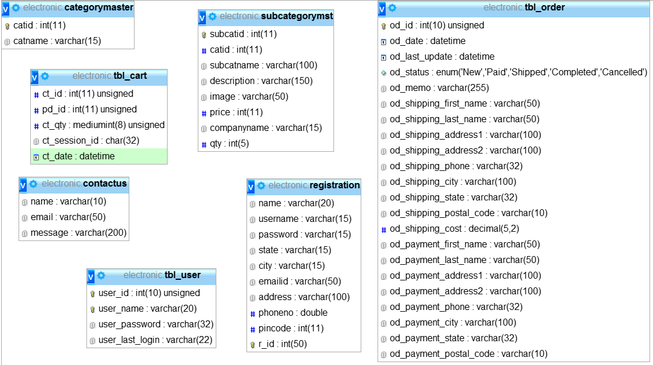

Fig 3.6 Class Diagram

3.2.3 Activity Diagrams



Fig 3.6 Login Activity:



Fig 3.7 Registration Activity Diagram:



Fig 3.8 Admin Activity Diagram



Fig 3.9 User Activity Diagram

3.2.4 Process Diagram

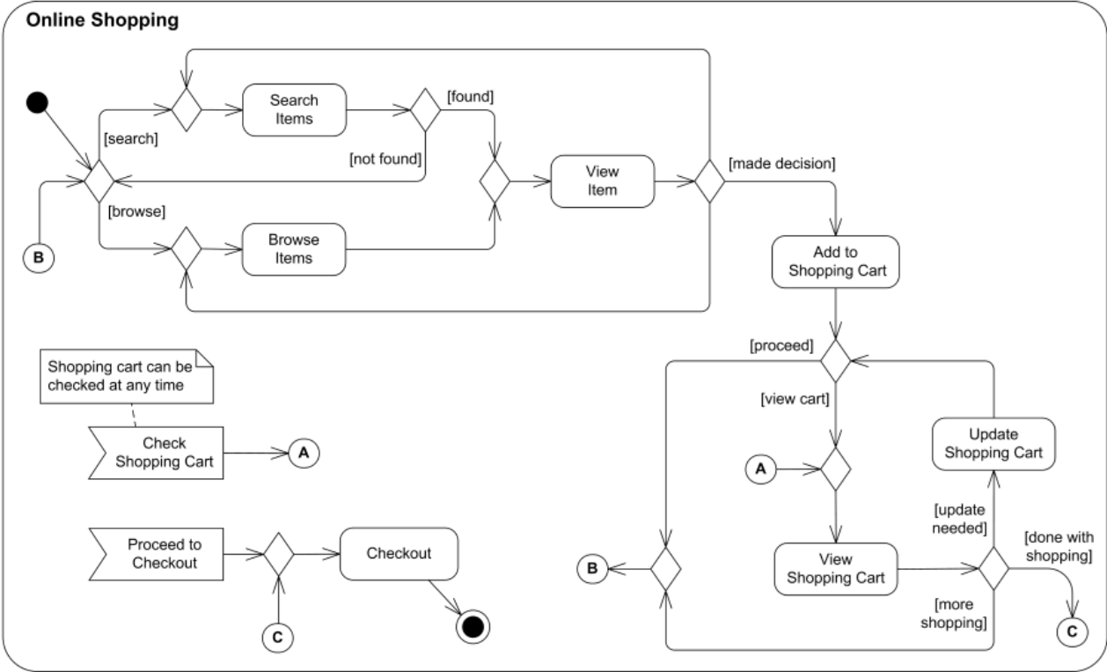

Fig 3.10 Process Diagram

4. USER MANUALS

**4.1 Menu Screens along with Description**

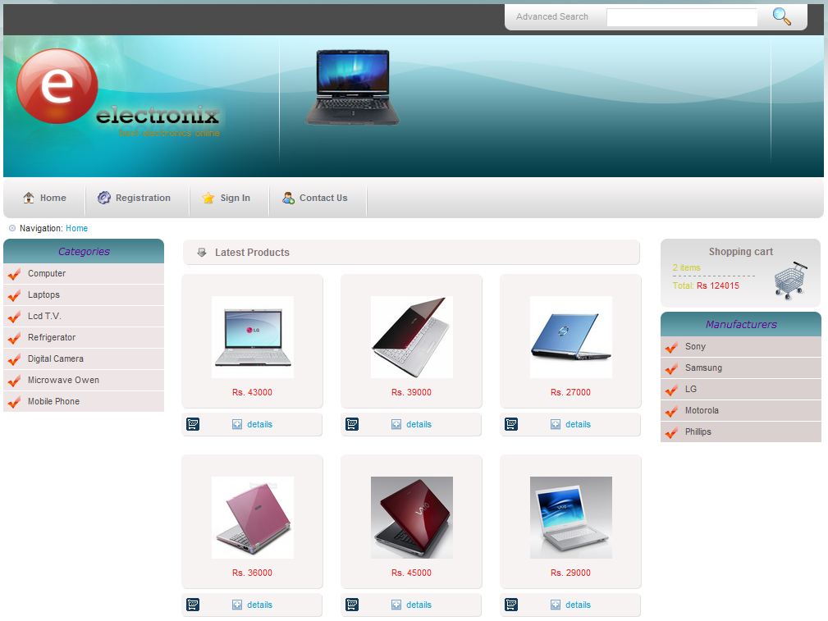

Fig 4.1 User Interface

**Description:** This is the user page where user can browse the various products based on the category.

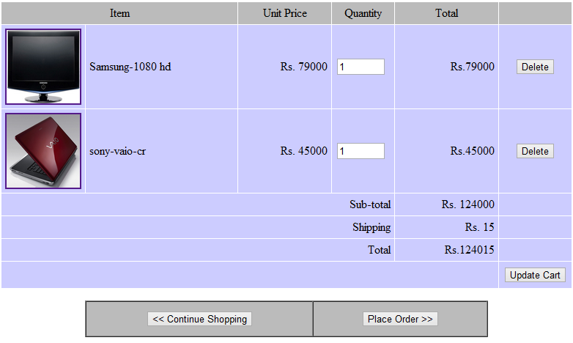

Fig 4.2 Shopping Cart

**Description:** This is the shopping cart page where list of products selected by the user is displayed.

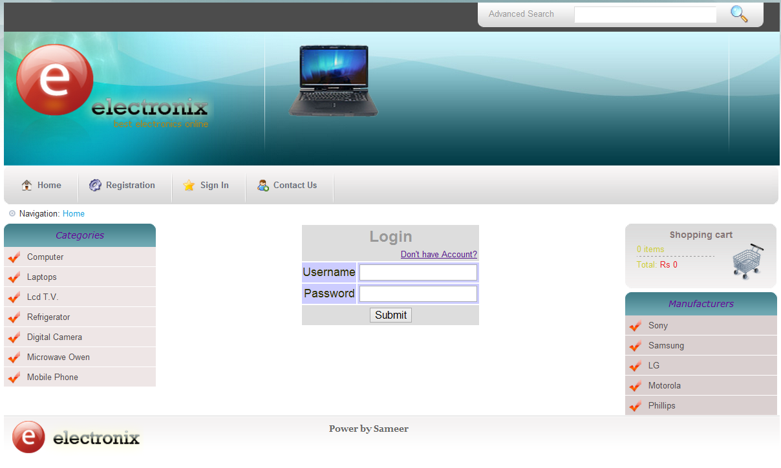

Fig 4.3 Login form

**Description:** This is the sign in page where users can sign in to place order of the selected item. For signing in user must be the registered user.

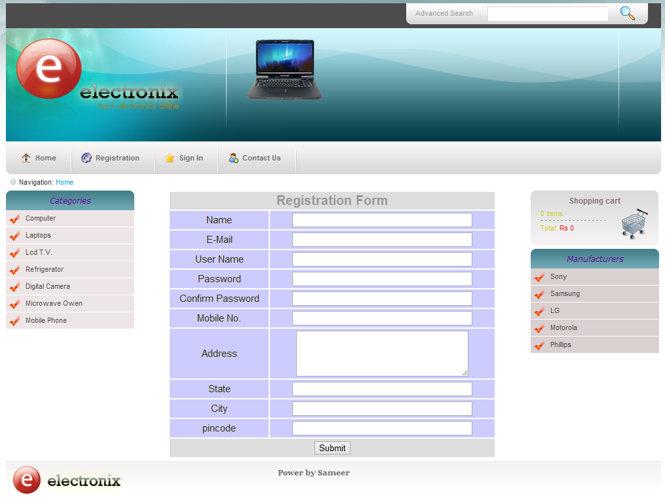

Fig 4.4 Registration form

**Description:** This is the registration form where user can register themselves so later they can sign in and order products

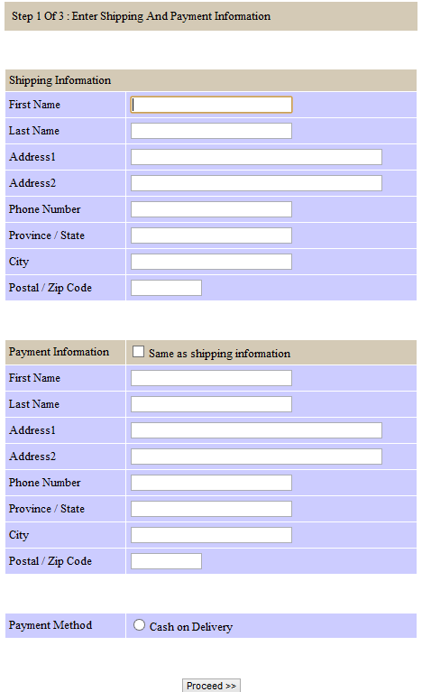

Fig 4.5 Shipping and Payment form

**Description:** This is the shipping and Payment form where users can enter his shipping and the payment information. He can select the payment type.

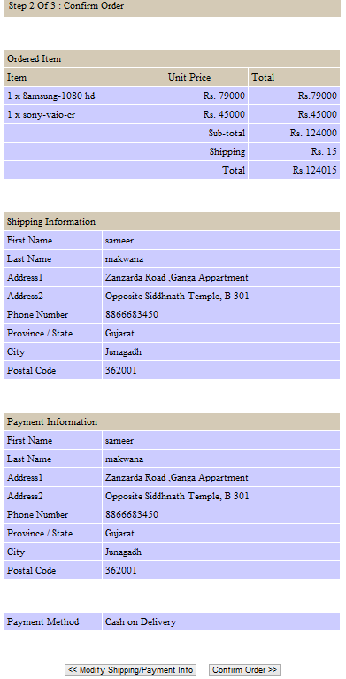

Fig 4.6 Shipping and Payment confirm

**Description:** This is the shipping and Payment confirm form where users can confirm his shipping and the payment information and the ordered items.

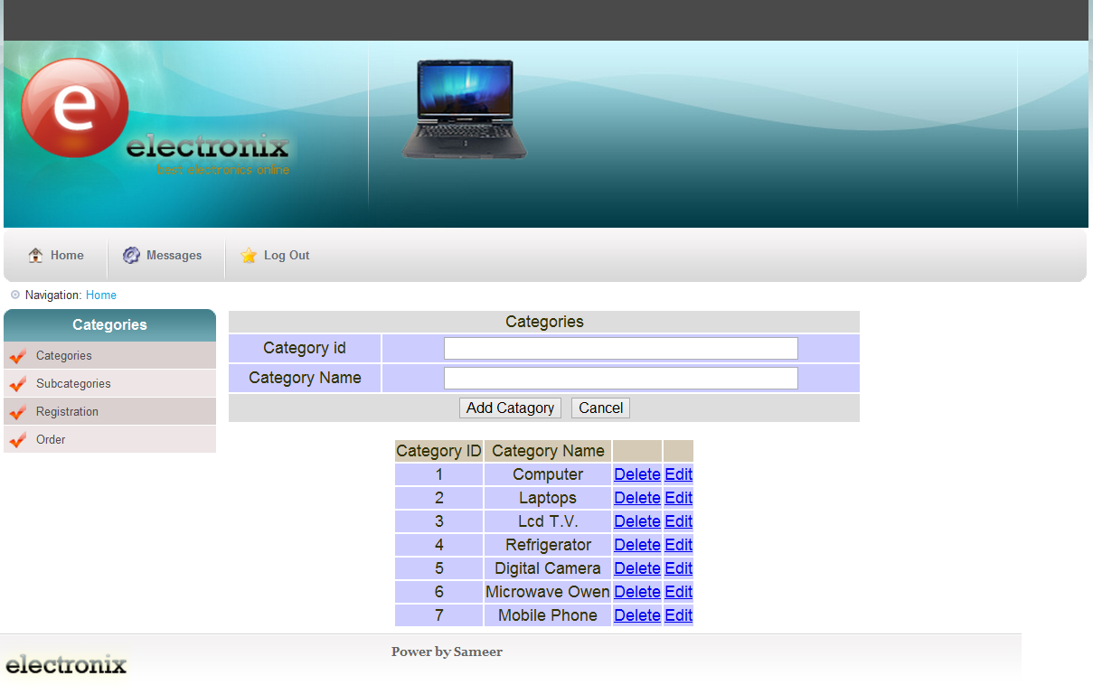

Fig 4.7 Category Management

**Description:** This is the admin category form where various categories can be inserted updated,deleted.

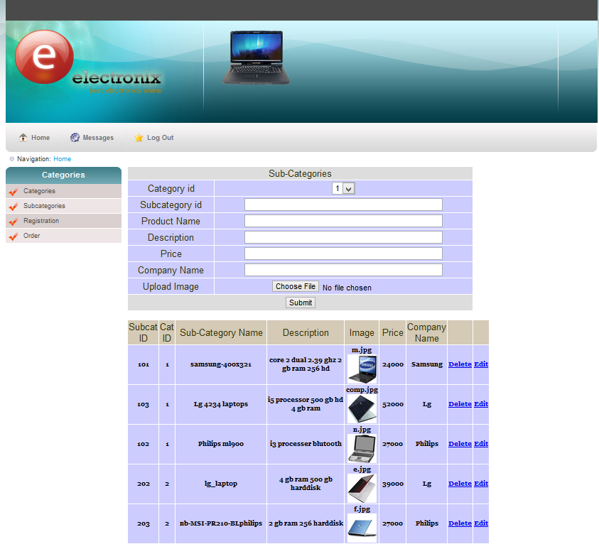

Fig 4.8 Product Management

**Description:** This is the admin product form where various products can be inserted, updated, deleted.

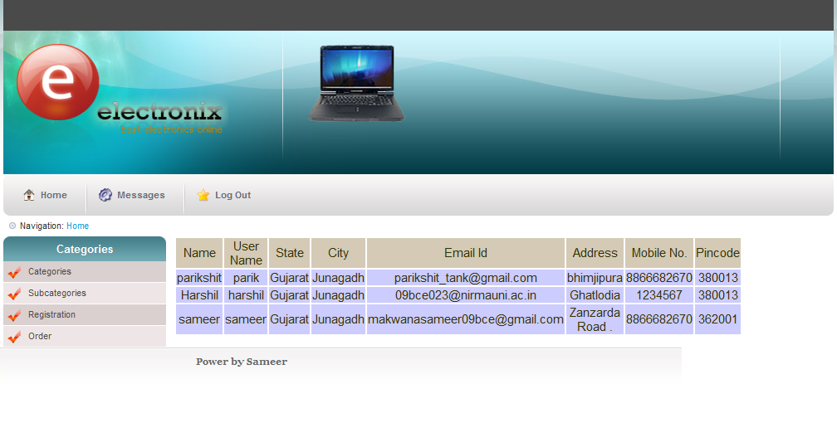

Fig 4.9 List of Registered Users

**Description:** Here the admin can see the list of all the registered users.

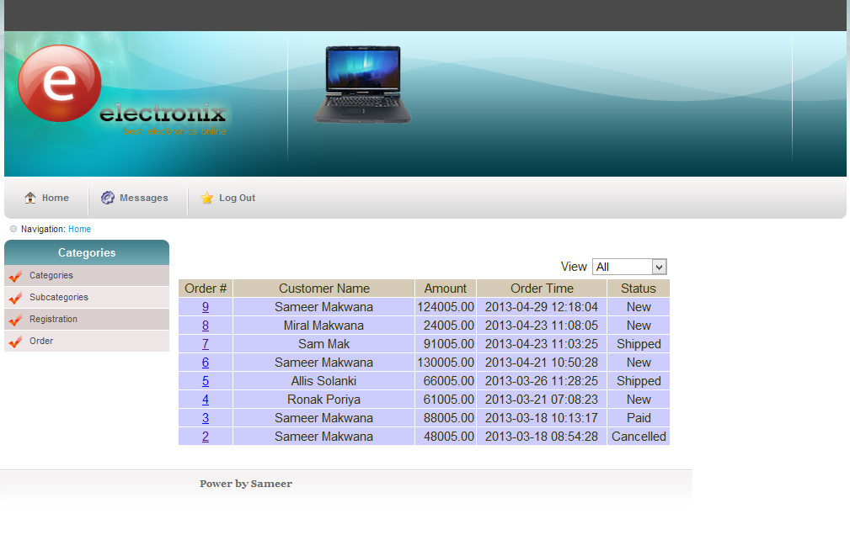

Fig 4.10 List of Order

**Description:** Here the admin can see the list of various orders placed by the various users.

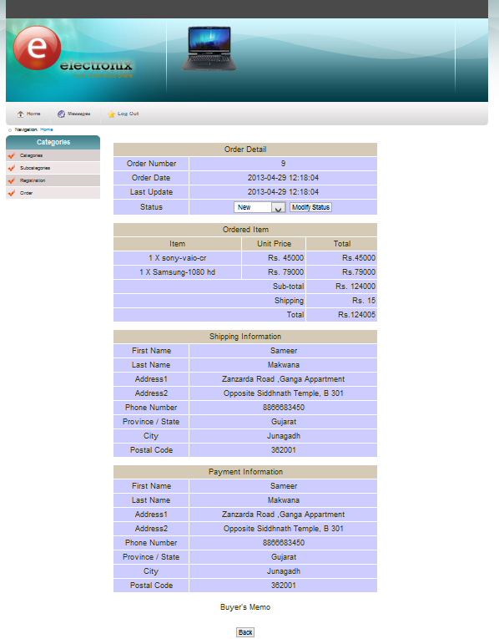

Fig 4.11 Order Details

**Description:** This page contains the detailed information about the ordered products.

**Chapter 5**

**TESTING**

|  |  |  |  |  |  |
| --- | --- | --- | --- | --- | --- |
| **Sr.No** | **Test Case Description** | **Input** | **Expected Behavior** | **Observed behavior** | **Test Result** |
| 1 | Can New User Register? | Personal Info of User | User should Be registered on DTIS server | User is Registered only If desired Id does Not collide with Existing Ids | Success |
| 2 | Can User Login? | Loginld + password | User should Be login | User is login only When Login Id & password is valid | Success |
| 3 | Can User Logout? | Logout Button | User should log out. | User Logged out | Success |
| 4 | Can User Add Products to Cart | Cart Button | User should be able to Add products | Added products will be displayed | Success |
| 5 | Can User Delete Products from cart | Delete Button | User should be able to delete products | Deleted records will not be displayed | Success |
| 6 | Can User Update Products in cart | Update Butoon | User should be able to update products | Updated records will be displayed | Success |
| 7 | Can User browse products according to category | Category module | User should be able to browse products | Result of browsed category will be displayed. | Success |
| 8 | Can user order products | Place Order | User should be able to place order | Result of the ordered invoice displayed | Success |
| 9 | Can User Read information available on the site. | Click the link | User should be able to Read information | Information will be displayed. | Success |
| 10 | Can Admin insert,update,delete category | Insert,update,delete buttons | Insert ,update,delete category | Action performed | Success |
| 11 | Can Admin insert,update,delete products | Insert,update,delete buttons | Insert ,update,delete products | Action performed | Success |
| 12 | Can admin change order status | Status menu | Change status | Status changed | Success |

**Chapter 6**

**FUTURE ENHANCEMENT**

There are some limitations for the current system to which solutions can be provided as a future development:

1. The system is not configured for comparison of the multiple items at this time. The above functionality can be incorporated ; so that user can compare the various items description and then add to the cart the more specific items he may have choosed.
2. The Website is not accessible to everyone. It can be deployed on a web server so that everybody who is connected to the Internet can use it.
3. Credit Card validation is not done. Third party proprietary software can be used for validation check.
4. Payment Gateway can be incorporated ,till now cash on delivery is only kept.
5. The Administrator of the web site can be given more functionalities, like looking at a specific customer’s profile.

**Chapter 7**

**APPENDIX**

**7.1 Tools used.**

Xampp Server (apache server, php 5.0 ,MySQL database)

**Xampp Server:**

* XAMPPs are packages of independently-created programs installed on computers that use a Microsoft Windows operating system.
* XAMPP is the package, Whose acronym formed from the initials of:
* Microsoft Windows (the operating system)
* Apache (web server)
* MySQL (open-source database)
* One of [PHP](http://en.wikipedia.org/wiki/PHP), [Perl](http://en.wikipedia.org/wiki/Perl) or [Python](http://en.wikipedia.org/wiki/Python_(programming_language)) (scripting language)
* PHP is a server side scripting language that can manipulate information held in a database and generate web pages dynamically each time content is requested by a browser.
* Other programs may also be included in a package, such as [phpMyAdmin](http://en.wikipedia.org/wiki/PhpMyAdmin) which provides a graphical user interface for the MySQL database manager, or the alternative scripting languages Python or Perl. On the other hand we have LAMP which is same as XAMPP but for Linux operating system and MAMP for MAC.

**PHP**

* PHP is a general-purpose [scripting language](http://en.wikipedia.org/wiki/Scripting_language) originally designed for [web development](http://en.wikipedia.org/wiki/Web_development) to produce [dynamic web pages](http://en.wikipedia.org/wiki/Dynamic_web_page). For this purpose, PHP code is embedded into the [HTML](http://en.wikipedia.org/wiki/HTML) source document and interpreted by a [web server](http://en.wikipedia.org/wiki/Web_server) with a PHP processor module, which generates the [web page](http://en.wikipedia.org/wiki/Web_page) document. It also has evolved to include a [command-line interface](http://en.wikipedia.org/wiki/Command-line_interface) capability and can be used in [standalone](http://en.wikipedia.org/wiki/Standalone_software) [graphical applications](http://en.wikipedia.org/wiki/Graphical_user_interface). PHP can be deployed on most web servers and as a standalone interpreter, on almost every [operating system](http://en.wikipedia.org/wiki/Operating_system) and [platform](http://en.wikipedia.org/wiki/Platform_(computing)) free of charge. PHP is installed on more than 20 million websites and 1 million [web servers](http://en.wikipedia.org/wiki/Web_server).

**MySQL Database**

* MySQL is a [relational database management system](http://en.wikipedia.org/wiki/Relational_database_management_system) (RDBMS) that runs as a server providing multi-user access to a number of databases. It is named after developer [Michael Widenius](http://en.wikipedia.org/wiki/Michael_Widenius)' daughter, my. The [SQL](http://en.wikipedia.org/wiki/SQL) phrase stands for Structured Query Language.
* The MySQL development project has made its [source code](http://en.wikipedia.org/wiki/Source_code) available under the terms of the [GNU General Public License](http://en.wikipedia.org/wiki/GNU_General_Public_License), as well as under a variety of [proprietary](http://en.wikipedia.org/wiki/Proprietary_software) agreements. MySQL was owned and sponsored by a single [for-profit](http://en.wikipedia.org/wiki/Business) firm, the [Swedish](http://en.wikipedia.org/wiki/Sweden) company [MySQL AB](http://en.wikipedia.org/wiki/MySQL_AB), now owned by [Oracle Corporation](http://en.wikipedia.org/wiki/Oracle_Corporation).

**Chapter 8**

**SUMMARY AND CONCLUSION**

**8.1 Summary**

Summary of activities carried out during major project training at Mekhia Solutions Private Limited can be listed as below:

* Initial Learning about the technologies and the tools.
* Requirement Analysis of the project.
* Project Design including GUI related design.
* Project Development (Coding).
* Testing of the project.
* Quality Related Work
* Final Documentation.

**8.2 Conclusion**

Throughout the process, I obtained the experience of working in a large organization and it was a great learning experience. This organization has widened my horizons of knowledge to a very large extent. Till now I was exposed to a small side of practical learning and with this project I have attained a lot of understanding from the practical point of view. This project will always remain an integral part of my resume and I hope my wonderful experience here would provide a boost to my career as well.

**Bibliography**

[1] www.plaincart.com

[2] en.wikipedia.org/wiki/Carts